Nama : Fawaz Al Rasyid

NIM : 1301213016

Queue.h

Queue.cpp

Main.cpp

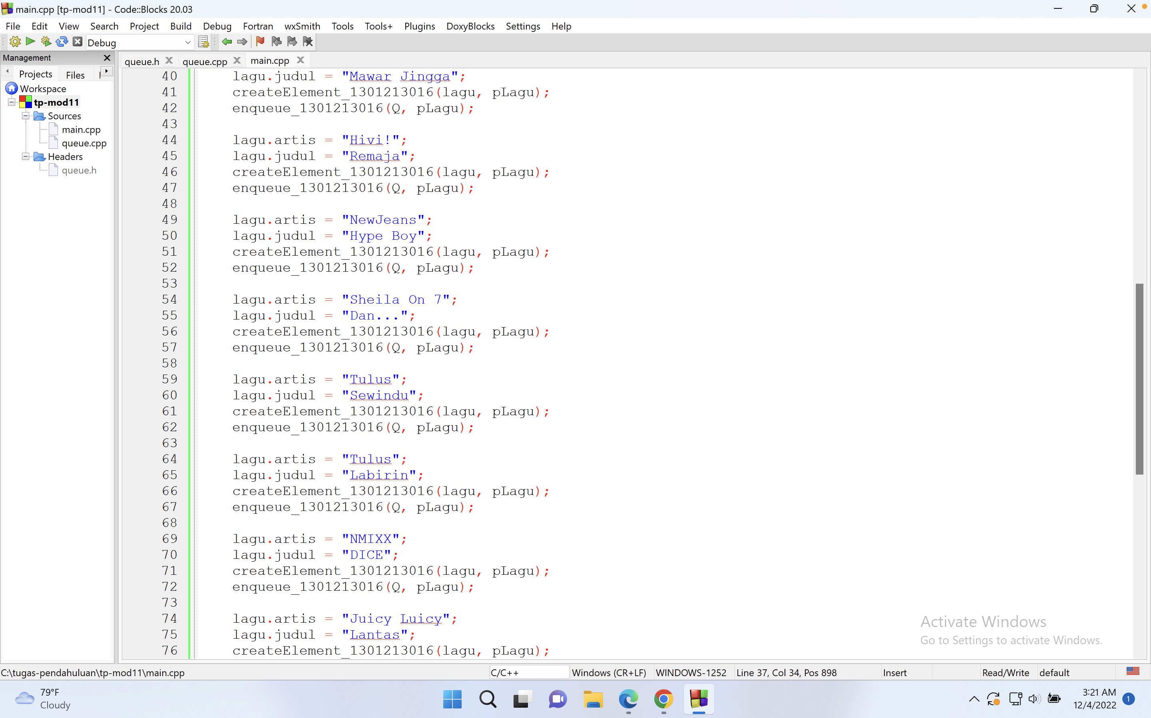

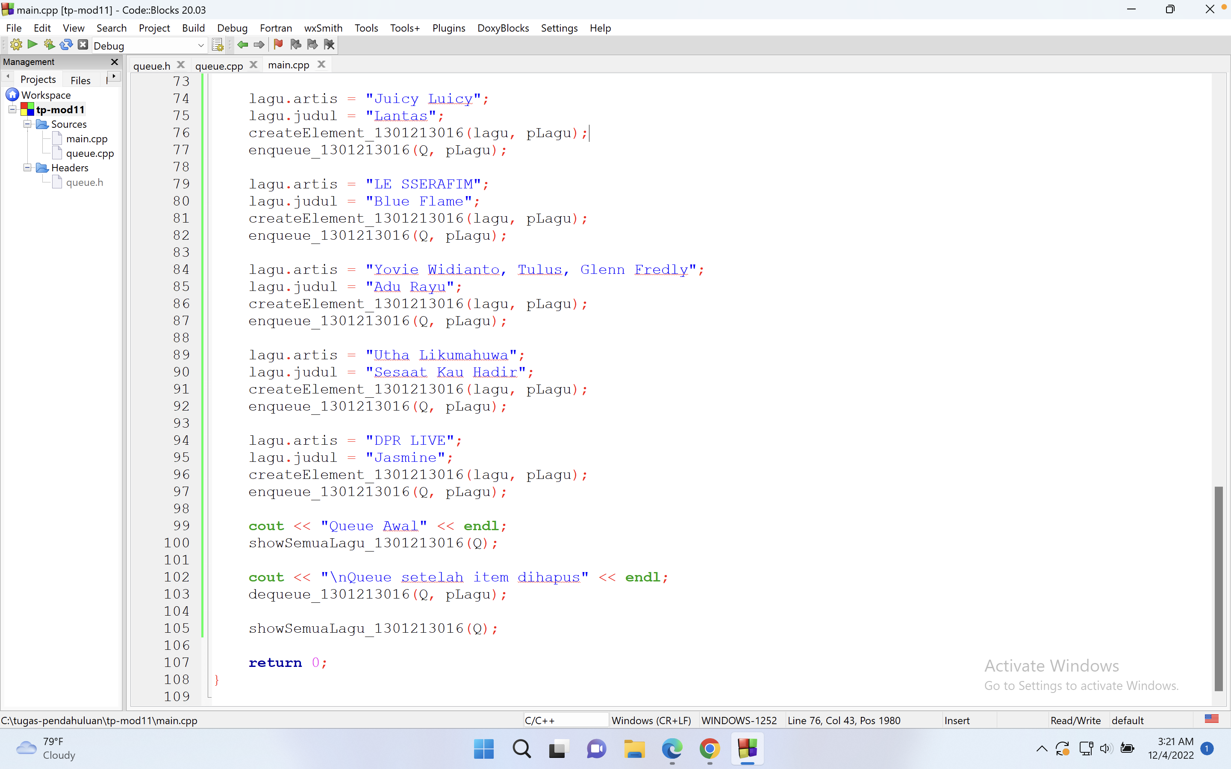

Output

